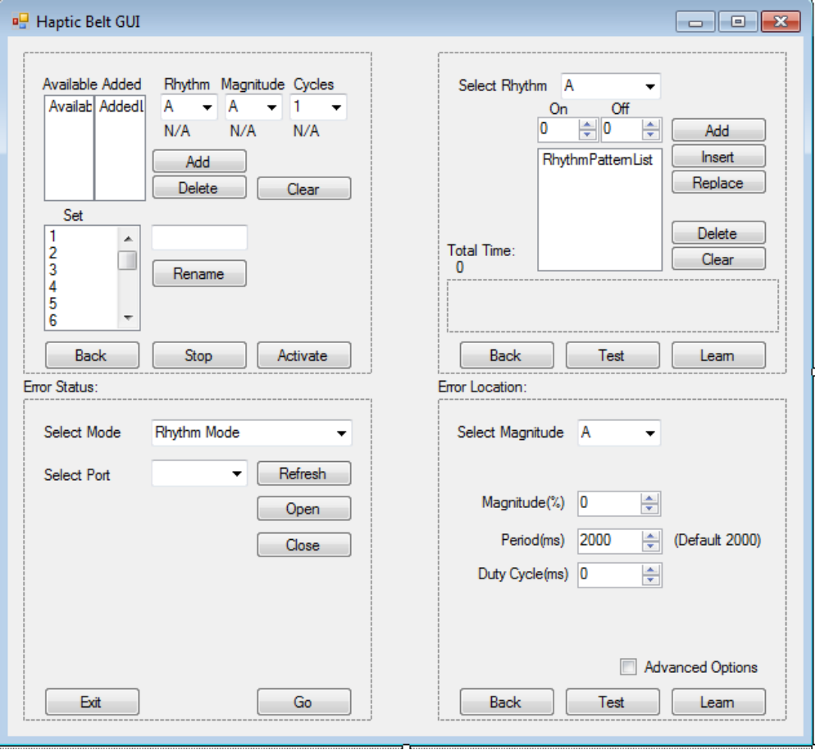
~Integration into new DLL
~Save/Load programmed motors in “Direct Mode”. This would be a great feature for setting up research experiments.
~What are we looking for as far as implementation of Spatio/Temporal features?
Due to the flexible configuration of the belt there is no precise way to have a 360 knowledge of the belt setup.
~Possibly adding one more level combining sets, into groups.
The GUI would need to detect when set ends, then send a request to start the next set.
This would involve precision timing, is this possible in higher level implementations?

Definitions:
A Set is 1 to N motors each with their own Rhythm Magnitude and Cycle attributes.
A group would be 1 to N Sets, initiating each set sequentially after the previous is finished.

